2.0 Structure

2.1 Organizational Chart
The following figure illustrates the organizational structure of PRAMP as of November 2020:
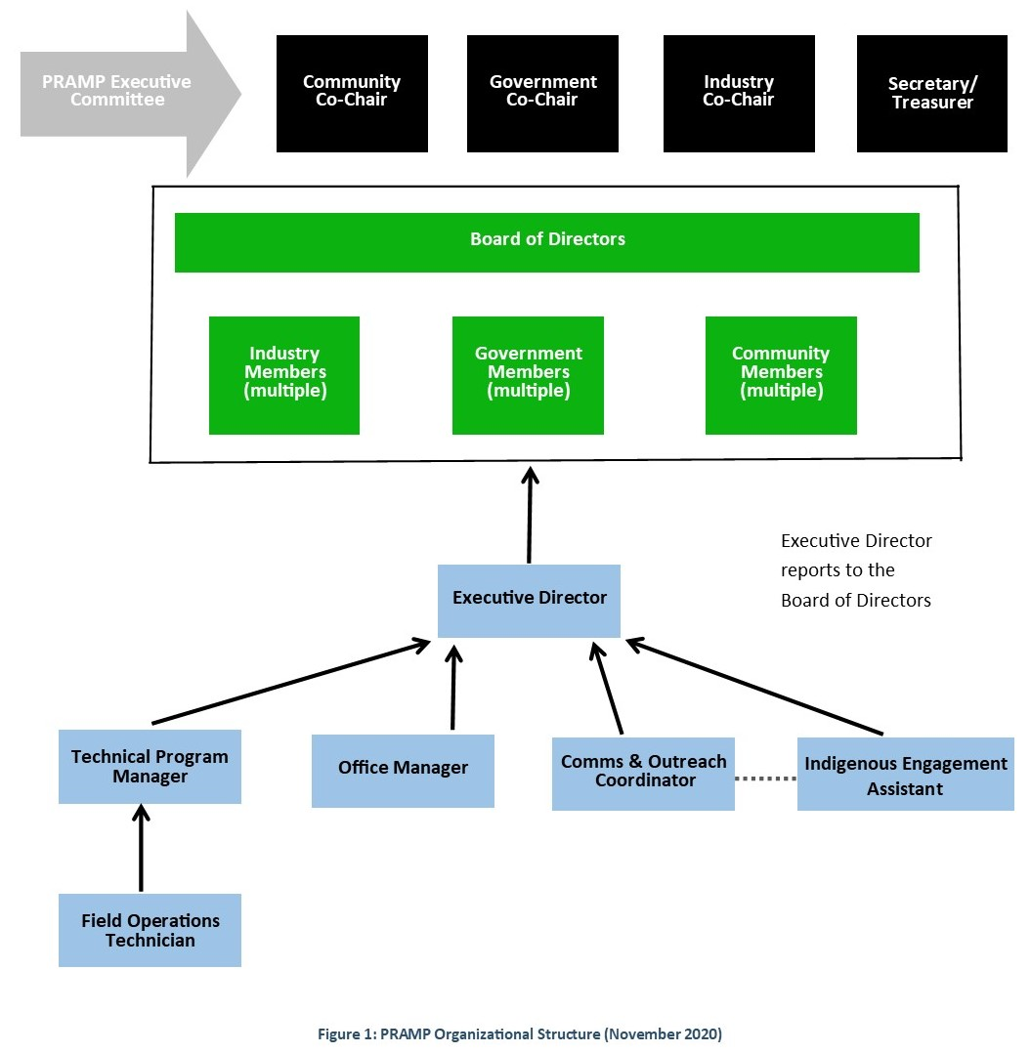

Each of the Industry, Government, and Community Member groups should have representation on the Board, and each should constitute no more than one-half of the Board. Directors serve for a two-year term. Members may sit as Directors for consecutive terms, with no limit.

2.2 Expectations of the Executive director
The Executive Director will work closely with the Board of Directors to achieve organizational objectives. Responsibilibities of the Executive Director include three key components as described below. Responsibilities may change from time to time through discussion with the Board of Directors.
Organizational Leadership - Oversee the day-to-day operations of the organization, including:
- Develop and implement strategies and tactics to ensure all PRAMP commitments are met
- Oversee all contracts and contractors; assist the Board with recruiting contractors and suppliers
- Ensure performance evaluations are conducted for all contractors
- Oversee record keeping, including the financial control system
Strategic Leadership – Develop and implement approaches to meet the long-term goals and objectives including:
- Maintain collaborative working relationships with related organizations, stakeholders, partners and community groups to ensure PRAMP’s interests are known and understood, and to maintain knowledge of air quality concerns and air quality management developments
- Develop and maintain a 3-year operating plan; provide regular progress reports to the Board
- Represent PRAMP’s intersts with all levels of government and the Alberta Airsheds Council
- Plan for emerging issues and continuus improvement
Communications, Education and Outreach – Oversee communication and engagement with the community, the Board of Directors, all levels of government and the media, including:
- Develop, implement and oversee a vibrant and innovative communications, outreach and engagement program
- Oversee the development of PRAMP’s newsletters, website content, social media and PRAMP’s involvement in community events
- Represent PRAMP at meetings, conferences and Airshed events as agreed with the Board of Directors

2.3 Expectations of the Board of Directors
The Board of Directors’ role is to provide direction and leadership, to respond to direction from its membership, to encourage communication to and among its members, and to elicit and encourage the contribution of all PRAMP Board and members. The Board makes clear distinction between its governing role and that of policy implementation and administrative functions as fulfilled by Contractors and Committees.
Each Director of the Board is a representative of the Society and shall act in the best interest of the Society at all times. The best interest of the Society includes the right and obligation of each Director to represent and act in the interest of their member organization and its stakeholders.
Each Director of the Board, in representing their organization's stakeholders, is also a representative of the Society and in the best interest of the latter shall:
i. Actively listen and bring forward those views and concerns of their stakeholders that directly relate to the objectives and goals of the Society;
ii. Actively keep their stakeholders informed of the activities of the Society;
iii. Act in the best interest of their stakeholders.
In addition, all Board Directors shall:
- Provide input into PRAMP Committee’s strategic direction, Bylaws, policies and budget and participate in regular planning processes.
- Ensure that the Board has proper Bylaws and policies; understand and apply them and other relevant legislation.
- Understand and support PRAMP Committee’s goal of the Society.
- Attend and actively participate in all required meetings of the Board and Committees.
- Speak with one voice—Board members may debate alternatives in the Boardroom; however, once a decision has been made, whether or not an individual Board Member is in agreement, s/he should respect and not speak against the Board decision to the greatest extent possible.
- Sit on the Society’s Committees or Working Groups as required.
- Acknowledge that they may be released at the end of the elected term, by resigning, or according to the PRAMP Bylaws.

2.4 Expectations of PRAMP Executive Committee
Officers of the Board oversee and direct the major aspects of the organization's operations. Board Officers, including Co-Chairs, Secretary and Treasurer, fill specific leadership roles.

Co-Chairs Provide leadership to the Board of Directors.

Makes sure the Board adheres to its Bylaws and Policies.

Chair meetings of the Board. The responsibility of Chairing meetings will be on a rotational basis.

Encourage Board member participation, including preparation of pre-meeting materials, completion of assigned responsibilities, and orientation of new Board members.

Keep the Board’s discussion on topics by summarizing issues.

Keep the Board’s activities focused on the Society’s goal.

Chair meetings of the Executive Committee as required.

Act as a signing officer for cheques and other documents.

Speak to the media and the community on behalf of the Society; represent the Society in the community.

Provide a monitoring function for contractors to do the following:
- Prepare the Board’s agenda
- Ensure appropriate committees are established; determine whether Executive Committee meetings are necessary and convene the Committee accordingly.

Orient the new Co-Chair(s).

Secretary Serve on the Executive Committee.

Act as a signing officer for cheques and other documents.

Provide a monitoring function for contractors to do the following:
- Keep copies of the PRAMP Bylaws and policy documents, providing copies to new Board Members.
- Keep lists of Executive Committee and Board Members.
- Notify Board Members of meetings.
- Keep record of meeting attendance.
- Make sure there is quorum at meetings.
- Record all motions and decisions of meetings.
- File the annual return, amendments to the Bylaws and other incorporating documents with the Corporate Registry.
- Make sure members are notified of General Meetings.

Orient the new Secretary.

Treasurer Serve on the Executive Committee.

Act as a signing officer for cheques and other documents.

Provide a monitoring function for contractors to do the following:
- Keep accurate accounts of receipts and disbursements.
- Make sure all necessary financial reports are filed.
- Oversees the Board’s review of, and action related to, the Board's financial responsibilities.
- Ensure appropriate financial reports are made available to the Board.
- Ensure that year-end audit or review is conducted in agreement with PRAMP Committee’s Bylaws.

Present audit of Financial Statements at the Annual General Meeting.

Spearhead the budget process.

Orient the new Treasurer.

2.5 PRAMP Committee and working group Guidelines
In order to ensure the PRAMP Committee and Working Groups are operated effectively and efficiently, the following general guidelines are to be followed:
- Working Group Chair: Working Group Chairs will be delegated by the Board of Directors. The Chair will report to the PRAMP Board all recommendations of the Working Group.
- Time Management: Meeting Chairs will ensure that meetings start and end on time, and they will keep the discussion focused through the use of an agenda. All members must show up prepared for the meetings, reading required materials ahead of time and completing previously assigned tasks.
- Active Participation: All members will voice their viewpoints and represent the interest of their respective stakeholders. Members need to be committed to the overall objectives of the organization, not their individual agendas.
- Diversity & Inclusion: Members need to respect diverse viewpoints and encourage others to share their perspectives with respect to relevant issues.
- Celebration of Achievements: Members will have the opportunity to acknowledge contributions during meetings. The Chair will also ensure that the Committee and Working Groups’ progress is evaluated periodically.

