Peace River Area Monitoring Program (PRAMP) Committee
Technical Working Group Meeting

April 15, 2021
Zoom Video Conference

Meeting Notes
Attendees:
Name | Sector Group | Organization | Participation
Doug Dallyn | Public |  | Director
Anthony Traverse | Industry | Baytex Energy | Director
Krista Park | Gov | AHS | Director
Laurie Cherperdak | GOV | AHS | Guest
Madhan Selvaraj | GOV | AEP | Guest
Karla Reesor |  | Executive Director
Mike Bisaga |  | Technical Program Manager
Lily Lin |  | Technical Program Manager
Brenda Barber |  | Office Manager
Dwayne Stepaniuk |  | Field Technician
Regrets:
Name | Sector Group | Organization | Participation
Garrett Tomlinson | Gov | Metis Nation, Region 6 | Director
Elvis Thomas | Public | Woodland Cree | Director
Gaylene Whitehead | Gov | Northern Sunrise County | Director
Matt Flette |  | CNRL | Director
Blair Fortin | Industry | Trevita | Member
Hanna Liu | GOV | AER | Guest
These notes are provided as a summary of discussions of the PRAMP Technical Working Group. The views and ideas noted do not necessarily reflect the perspective of each Committee member. Decisions are taken by consensus.

1.1 Approve Agenda
No additions to the Agenda
1.2 Approval of Minutes
Minutes were provided prior to the meeting.
Motion to approve the December 16, 2020 Minutes by Krista Park. No blocks
1.3 Action Items
- Have been completed.

2 Standing Business
2.1 Administration and Planning
OSM Process for 2021-22
- Workplans have not yet been approved; decision will be made in May
- AEP has asked how a 12% reduction in funding would affect PRAMP. A reduction of that amount would impact PRAMP. We have not received any indication from AEP that there will be a reduction.
2.2 Continuous Monitoring Program
Dashboard Reports
The January, February and March dashboard reports were posted on the Members Portal.
986
- No issues to report

842
- One non-compliance event in January. TRS failed. Related to ambient temperature. Tech waited for better weather. One hundred and thirty-six hours of downtime were recorded.
- In February, the TRS analyzer failed the daily span check caused by low temperatures and lack of moisture in the sample air. One hundred thirty-eight hours of downtime recorded.
- In March, no data recorded possibly due to Windows update. Five hours of downtime recorded.

Reno
- In January, the TRS analyzer had an issue due to extreme cold temperatures. Zero check results between January 24 – 31 were excluded from baseline correction
- In February, the TRS analyzer failed due to extreme cold. TRS did not meet the 90% operational uptime.
- THC/CH4/NMHC sample pump failure. Forty-two hours of downtime recorded.
- TRS analyzer failed daily span check. Data invalidated for March 4 and 5. Forty-five hours of downtime recorded.
AQHI
- In January, there was a calibration equipment error for the Nox analyzer. Downtime of fifteen hours was recorded
- The THC/CH4/NMHC analyzer failed due to depletions of carrier gas. Thirty-five hours of data were invalidated.
- In March, the PM2.5 analyzer crashed resulting in 26 hours downtime.
- Further analysis of the Cadotte Lake TRS data is planned; there are similar patterns in the data over the same period of time last year. The results will be included in the AQHI station wrap up report.
- Lower acceptable limit will be set for CH4 from 1.8ppm to 1.7ppm; will also affect the THC readings. The limit was set for the daily data review and allowed some leeway for later zero correction. This will be discussed further in the 2020 data report review.
Action item: The order of stations on the dashboard will be changed (move the PRC station to the end as we do not have data)
Review canister results
- In January, one NMHC-triggered event was recorded at 986c.
- In February, one NMHC-triggered event was recorded at 986c.
- No canister event in March.
AQHI Re-deployment
- Summary of the feedback of redeployment of the AQHI station.
- Redeployment will be postponed until May or June to ensure PRAMP has proper funding.
- Review of the information collected in stakeholder interviews and online survey.
- Sites where the air quality concern(s) can be addressed by a small sensor (i.e. dust/smoke) have not been included in the matrix weighting.
Action item: Update the map with current industry facility location information.
- Review of the matrix document for each site.
- Note: modelling or emission data isn’t included on the matrix; complaints from odour issues may not be identified (i.e. residents no longer complain). Mike will review and see how he can integrate modelling as well as existing emission data.
- The matrix was not applied to sites where the nature of the air quality issue is smoke/dust as these can be addressed with small sensors.
- The policy indicates that the TWG will decide on a deployment plan and inform the Board.
- There is support to put the portable in Grimshaw, but we will hold off the decision until PRAMP has further discussions with Mercer.
- Table summarizing feedback from surveys/consultation, matrix score (count indicates the number of times the issue appeared in feedback):
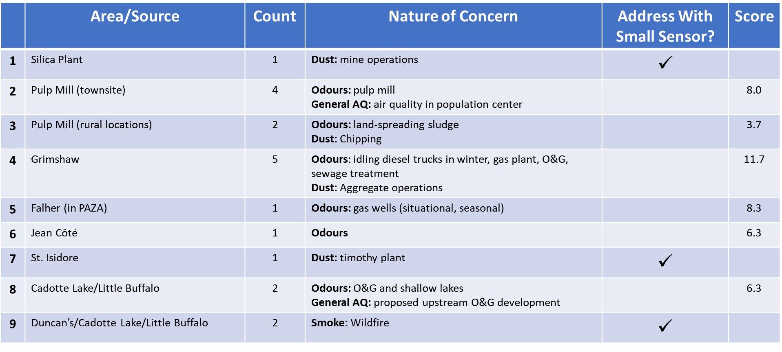
Action item: AEP will share the emissions and modelling information with PRAMP.
Reno Siting
- Reno monitoring station does not meet the AMD siting criteria.
- Presented new proposed monitoring location (northwest of existing site)
- Costs to move to the new site or staying at the existing site and making it compliant with the AMD were compared.
- Proposed next step will be to talk to the landowner at the new proposed site to find out if the station could be set further west (more than 100m from the house); cost analysis on removing the trees or extending the road
2.3 Canister Sampling Program
Have engaged a chemist, Court Sandau with Chemistry Matters to evaluate the isotope program. Will be arranging a sample collection south of Reno as source signature. Have provided him with all the VOC data from the last few years.
Court Sandhow was engaged in evaluation prior to the Hearing so is very familiar with the program.
2.4 Annual Data Review
- The technical program managers (TPMs) intend to use the same format as last year for the annual data review.
- The technical working group to look at the 2018-2019 report and provide any comments for the content and structure of the 2019-2020 report to the TPMs.

3 AQHI Station Report
- Focus on the monitoring context and the AQHI results.
- Detailed analysis will be in the annual data review not in this report.
- This report will be significantly shorter than the annual data report.

Closing
3.1 Roundtable
Much appreciation of the discussion today. Thanks to Mike and Lily for the preparation for this meeting.
3.2 Next Meeting
Three to four weeks; we will doodle for a date.
Adjournment
Meeting adjourned at 3:59 pm by Karla Reesor.

Action Item Date | Action Item Description | Responsible | Status
 | New Action Items
2021-04-15 | The order of stations on the dashboard will be changed (move the PRC station to the end as we do not have data) | PRAMP TPMs: Mike B and Lily | NEW
2021-04-15 | Update the map with current industry facility location information. | PRAMP TPMs: Mike B and Lily | NEW
2021-04-015 | AEP will pull share emissions and modelling information with PRAMP. | AEP: Madhan S | NEW
 | Completed Action Items
2020-12-01 | Karla will develop a letter to send to our partners and stakeholders about the criteria on setting up the portable AQHI monitor
2020-12-02 | Karla will provide Gaylene Whitehead with the membership form.
2020-09-01 | Mike and Lily will get a quote for the removal of the trees at the current Reno monitoring site, and review all other costs; including power and road upgrade the site
2020-09-02 | Mike will ask the landowner if it would be possible to site the new Reno station across the road from the location originally looked at.
2019-12-01 | Mike and Lily will develop a proposal for a co-deployment with objective to address siting issues at Reno. Timeline is end of January
2019-12-02 | Mike will follow up with Elvis about the tree issue at Woodland Cree
2019-05-01 | Mike will talk to Corinna Williams to see if the County will willing to do dust control at preferred AQHI trailer site at Codette Lake.
2019-05-02 | Karla will speak to CNRL to see what they wish to do with the power meter at 986B.
2019-01-01 | Mike will follow up with the other property owners (where stations are located) and discuss the option of payment for land rental.
2019-01-01 | Lily and Mike will explore the cost of adding precipitation readings (rain gauges) to the entire network.
2019-01-01 | Mike and Lily will prepare a one page document on recommended site for the AQHI trailer for Board, members and municipalities.
2019-01-01 | Mike and Karla will look into the information to be provided to AER on background canisters.
2018-11-01 | PRAMP staff will continue to work with legal counsel to develop a new contract with Maxxam going forward
2018-11-02 | Mike and Lily to pursue option 1 and move on to second if it doesn’t work out for relocation of station 986
2018-11-03 | Lily and Mike will apply the matrix to the sites identified within the TWG for the siting of the portable monitor
2018-11-04 | Lily will send the siting requirement document for the portable monitor to Elvis Thomas
2018-11-05 | Krista will request a comprehensive document of the canister sampling program including the review of each canister with Laurie Cheperdak
2018-11-06 | Brenda will provide Laurie Cheperdak’s email address to TWG
2018-06-01 | Mike and Lily will make a recommendation on a methane-based trigger for the canister program. The same trigger will be set at all the stations.
2018-06-02 | Mike and Lily will review the relationship between TRS and NHMC concentrations and report back to the TWG at the next meeting.
2018-06-02 | Mike and Lily will research the additional cost to continuously monitor VOCs
2018-06-03 | Maxxam will put a disclaimer that the data is raw on the dashboards going forward
2018-06-04 | The TWG will review the Portable Station Locating Procedure prior to the September meeting
2018-03-01 | Mike will talk to Bob Myrick about adding the government logo to the signs.
2018-03-02 | Karla and Brenda will research a menu option phone number
2018-03-03 | Mike will review the history of data and based on conversations today will come back with a recommendation.
2018-01-05 | Mike will come back to the TWG with recommendations on reasonable trigger levels
2018-01-01 | Maxxam will trigger the canisters that are set to expire as a test.
2018-01-02 | Mike will resend the sensor drawings to Reid
2018-01-03 | Mike will do research on signs and/or wraps for the stations
2018-01-04 | Mike will look into a second trigger on canisters related to hydro-carbons
2017-11-01 | Mike will add the approval process to the TORs. Will send with the draft minutes for approval.
2017-11-02 | Mike will make a recommendation to the Board on the procedures for the TWG to report to the Board
2017-11-03 | Lily will ask Maxxam to provide a system design including the location of the new sensor. The TWG will approve via email before Maxxam does the installation.

