Terms of Reference
Peace River Area Monitoring Program
(PRAMP)
Revised November 2020

Note from the Executive Director: These Terms of Reference were prepared to reflect the expectations of the AER following the AER proceeding in 2014. PRAMP has grown and evolved significantly since that time. Rather than updating this document, it may be appropriate to carefully review the Terms of Reference in a Strategic Planning Session with the PRAMP Board. Such a session could be arranged for Q1 2021.

INTRODUCTION:
These Terms of Reference for the Peace River Area Monitoring Program (PRAMP) have been developed and will be implemented to satisfy the monitoring and modelling recommendations contained in Decision 2014 ABAER 005: Report of Recommendations on Odours and Emissions in the Peace River Area (March 31, 2014). The Peace River Area was initially defined in paragraph [5] of the Decision as the Three Creeks, Reno, Seal Lake and Walrus areas, as depicted in Figure 1. In paragraph [11] the Panel decided that the nature and sources of odours and emissions associated with heavy oil operations, including the transportation of energy resources from these operations, and the monitoring of those emissions in the area were within the scope of the Proceeding. In paragraph [171] the Panel states that a robust monitoring program is critical to ensure that emission-related problems are identified, corrective measures are taken, and compliance with the requirements, including the recommendations in this report, are achieved.
The Panel’s recommendations may also apply to areas outside of the defined Peace River Area where development of heavy oil and bitumen occurs within the Peace River Oil Sands Area 1 and 2 (paragraph [32]), also shown in Figure 1. The boundaries of the monitoring program may be expanded to areas where people might be exposed to odours and emissions, based upon results of the geology recommendation.
The Peace River Area Monitoring Program will be overseen by a Committee with these Terms of Reference that were developed with the Three Creeks Multi Stakeholder Air Monitoring Sub-Committee (Sub-Committee), based on their current program. The Mission, Goals, Objectives and Strategies in “italic font” are from the Decision paragraphs [176]-[178] and are followed by the interpretation of the Committee. The Vision, Scope of Monitoring, Committee, Membership List and Operations are also discussed. These Terms of Reference are for the formation of the program and may be changed by the Committee in subsequent years.
The terms odours and emissions require definition for these Terms of Reference. Odours are detected in the ambient air by the people in the area. Emissions at a source are defined by the concentration and flow rate of each compound released. Upon release from the source the emissions disperse downwind and may be measured as a concentration in the ambient air by a monitoring device. When the word emissions is used it will be clarified as to whether source or ambient measurements apply.

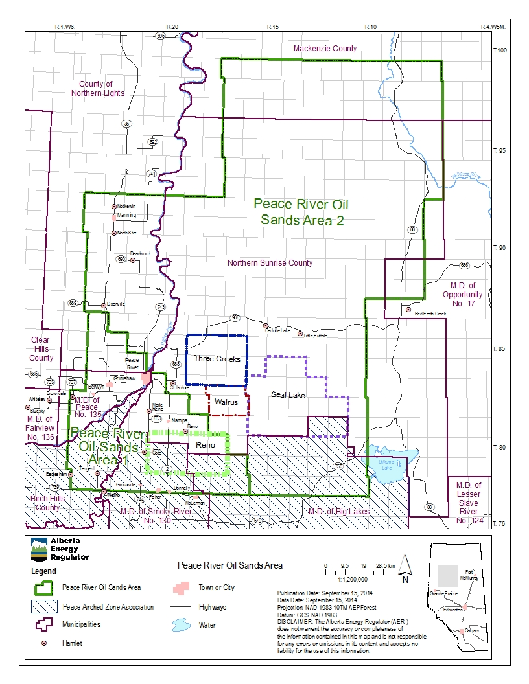 Figure 1 Peace River Oil Sands Area

In 2020, the PRAMP Board of Directors approved new boundaries for the Airshed to reflect heavy oil operations as well as community interests in the region. PRAMP collaborated with the Peace Airshed Zone Association (PAZA) and area stakeholders to re-define the PRAMP and PAZA boundaries in a way that avoids overlap. The new boundaries are shown in Figure 2.
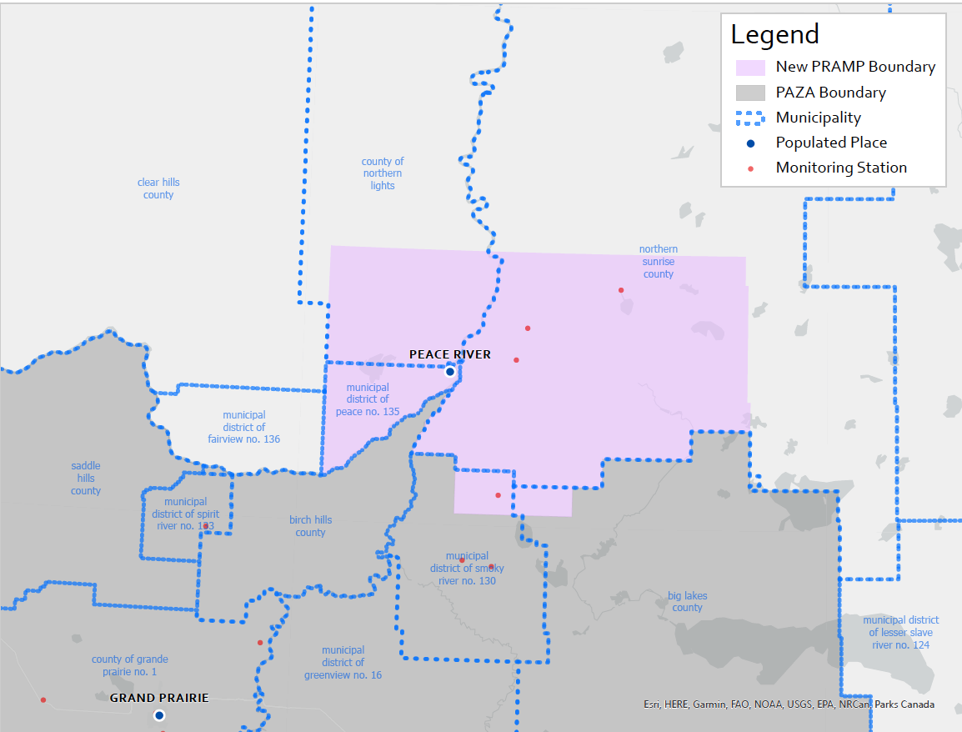
Figure 2 PRAMP Boundaries

VISION:
The Peace River Area heavy oil and bitumen operations’ emissions will not cause odours that affect human health.
MISSION:
“The Peace River Area will have an air quality monitoring program that provides credible and comprehensive data to permit the identification and appropriate response to odour and emission related issues.”
PRAMP accepts the Panel’s mission statement. PRAMP will monitor emissions in the ambient air and estimate source emissions from heavy oil and bitumen production operations in the Peace River Area. The data will be evaluated to manage source emissions to minimize odours.
SCOPE OF MONITORING
Currently, the Peace River Area Monitoring Program consists of: continuous monitoring to determine the concentrations of hydrocarbons and sulphur gases present in ambient air; intermittent canister sampling to determine concentrations of volatile organic compounds; and supporting meteorology measurements. Concentrations of hydrocarbons are reported as total hydrocarbons (THC) and non-methane hydrocarbons (NMHC), both as parts per million of methane. Sulphur gases are reported as total reduced sulphur (TRS) compounds as parts per billion of hydrogen sulphide (H₂S) and sulphur dioxide (SO₂) as parts per billion of SO₂. The ambient air is sampled intermittently when continuously monitored hydrocarbon concentrations exceed a set point that triggers an air sample to be collected in a canister. The intermittent canister samples are analyzed for volatile organic compounds and reported as parts per billion. Meteorological measurements include wind speed/direction and ambient pressure and temperature. PRAMP currently operates two monitoring stations in Three Creeks area and one in the Reno area.
Other industrial emitters in the area such as the pulp mill and agricultural operations are not participating in PRAMP at this time, but the scope of monitoring may change, as determined by the Committee.

GOALS:
“The air quality monitoring program would”
- “Assist in verifying that air quality is improving and odours are being minimized as a result of operational and regulatory improvements.”
Continuous ambient monitoring results for total hydrocarbon, non-methane hydrocarbon and sulphur compounds will be analyzed to determine trends over time. Odour complaints will be correlated to monitoring results to verify that operational and regulatory improvements are effective.
- “Operate transparently and give residents and stakeholders timely access to data and information in a manner that is readily understood.”
PRAMP’s operation will be transparent to the members and the public. A communication plan will be developed to provide real-time access to monitoring data on a website. Regular, readily understood summaries of monitoring results from Goal #1, 3 and 4 will also be provided.
- “Demonstrate that operators have effective control mechanisms.”
The ambient monitoring results and odour complaints will be analyzed to determine if source control mechanisms for emissions result in improved air quality (see Goal #1 above). Results of AER odour inspection sweeps of facilities will be reported.
- “Verify that air quality is at acceptable levels and that emissions residents are exposed to are below toxic thresholds.”
Canister sampling for volatile organic compounds and reduced sulphur compound concentrations will be compared to health exposure thresholds defined by Alberta Health. Alberta Health will review relevant information available from other jurisdictions, and recommend suitable health exposure thresholds. PRAMP will compare measured compound concentrations to the recommended exposure thresholds to provide an indicator of what compounds are a potential health concern. Odour thresholds from the Proceeding and the Stantec report will also be compared to measurements.
- Maintain its status as an independent Not-for-Profit Organization and Airshed that is focused on continuous improvement and responsible growth.
Based on the outcome of Goals 1, 3 and 4, PRAMP may modify the monitoring network and the canister sampling/analysis program, recommend additional studies for specific compounds, and/or recommend further emission source controls.

OBJECTIVES:
“To accomplish these goals, the monitoring program would”
- Characterize emissions and odours associated with industrial activity, with a focus on oil and gas operations.
Odours and emissions (both source and ambient) for the Reno area were characterized in submissions the Panel considered at the Proceeding. The Three Creeks Multi Stakeholder Air Monitoring Sub-Committee conducted emission studies in 2014. These studies will be used to support tracking month to month source emissions using publicly available monthly flaring, venting, and production rates. Canister monitoring of volatile organic compounds at the source and in the ambient air will be compared.
- “Identify and measure dominant sources of emissions in the area.”
Source emission contributions due to truck loading/unloading and fugitive emissions will be estimated based on the studies mentioned in objective #1 to identify the dominant sources. Ambient monitoring will also be used by PRAMP to identify remaining sources of emissions in the area by using pollutant roses that show the wind direction sector the emissions originated from.
- “Give timely, real-time data on ambient emission and odours in the area.”
A communication plan will be maintained to provide real-time access to monitoring data and regular summaries of monitoring results in understandable terms.

STRATEGIES:
“The Panel recommends that the AER engage industry, residents, and stakeholders to establish a scientific and technically credible regional air quality monitoring program for the Peace River area that, to the extent possible,”
a) “builds on the efforts of the existing continuous air monitoring program” PRAMP builds on the effort of the previous Three Creeks Multi-stakeholder Air Monitoring Sub-Committee’s continuous air monitoring program.
b) “includes the Reno area” Baytex has installed a continuous air monitoring station in the Reno area, with the same capabilities as the two stations installed in the Three Creeks area.
c) “considers the studies and monitoring surveys conducted to date by ESRD, industry, Stantec, RWDI, Clearstone, Chemistry Matters, Odotech, and Dr. Zelt” The Stantec report by the Sub-Committee summarized all of the monitoring done in the Three Creeks area up till 2013 and provides recommendations that the Committee will address. The Clearstone reports by the Sub-Committee provide an emission inventory for the Three Creeks area and field measurements of truck loading and tank cleaning emissions. Committee members will use the studies as necessary.
d) “provides greater geographic and spatial coverage by monitoring in areas of anticipated highest concentrations and where people might be exposed to odours and emissions” Dispersion modelling by RWDI and Dr. Zelt studies mentioned in item c) indicated that the greatest impact will be on the residents nearest to the sources. As indicated in the Introduction, AER may direct PRAMP to expand the area to monitor in areas where people might be exposed to emissions and odour.
e) “is operated collaboratively by industry, residents, the AER, and other government agencies (using a Clean Air Strategic Alliance [CASA] type model)” The governance of PRAMP described in these Terms of Reference are based on the CASA model. Note that as with other air sheds, it is a condition of the AER approval that operators participate in the regional monitoring program.
f) “provides transparent and real-time data to residents and stakeholders” A communication plan will be developed to meet this requirement. Data will be routinely analyzed and interpreted for sharing with the public.
g) “assesses innovative monitoring technologies to better understand odours and emissions sources, and use the technology where appropriate” The initial year of operation will focus on improved communication and data management. Innovative monitoring technologies will be identified and assessed in subsequent years.
The Committee may also work with other Airsheds such as the Peace Airshed Zone Association to minimize duplication of effort in developing the communication and data management plans.
FUTURE CONSIDERATIONS
Progress Review
Monitoring results will be reviewed annually to determine if PRAMP’s goals and objectives are being met.
AEP Collaboration
Alberta Environment and Park is the provincial organization responsible for air, water, land and biodiversity. PRAMP will work in collaboration with AEP to continue providing air monitoring and air quality management within the Peace River region.
Odour Units
Odour units are a measure of how many times a source or ambient sample must be diluted before it is not detected by a panel of trained analysts. Source odour units for casing and tank top gas and ambient odour unit dispersion modelling predictions were provided in the Reno area emissions studies considered during the Proceeding. Venting of tank top gas was shown to be a dominant source of odours, thus venting was eliminated. PRAMP may assist and support further work relating to odour units as future opportunities are identified by AEP and/or Alberta Health.
OPERATIONS
PRAMP will prepare an Operating Plan that details the tasks to collect and analyze the monitoring data. It will include a Network Assessment, a Monitoring Plan (both meeting AEP requirements), a Data Management Plan, a Communications Plan and a 3 year Strategic Plan.

APPENDIX 1
PRAMP TARGETTED MEMBERSHIP LIST BY GROUP

COMMUNITY
Public members in Three Creeks area
Public member in Reno area
Public member(s) in other areas
INDUSTRY
Baytex Energy
Canadian Natural Resources Limited
Obsidian Energy
Other Companies with an AER Approval PRAMP membership requirement
Other Service Companies acceptable to the Committee
GOVERNMENT
Alberta Health Services
Northern Sunrise County
Town of Falher
MD of Smoky River
Town of Grimshaw
First Nations and Metis Communities
Other municipalities where monitoring occurs

