EXTERNAL MEMO

To: Mike Bisaga Company: PRAMP

cc:

From: Randy Rudolph Company: Millennium EMS Solutions

Date: 31 October 2018 Reference Number: 18-00197

Re: Production and Emissions in Expanded PRAMP

Urgent For Review Please Comment
Please Reply Please Recycle

Project Understanding
MEMS has previously prepared information relating to well production volumes in the Peace River airshed, as an aid to understanding air quality observations at several monitoring sites in the area and to investigate an initial geographical expansion option.

PRAMP is currently considering an expansion north to the NWT border, and a revised southern border to account for a northward expansion of the PAZA airshed.

PRAMP wishes the gas and oil well production information and flaring and venting emissions in the expanded area to be extended to include information on venting and flaring volumes during the period 2010-2017. A northward expansion also means that emissions from other source types (primarily forestry, traffic and communities) need to be considered.

Approach
Oil and Gas
Data from the following main sources will be accessed:

- Data pertaining to oil and gas wells and facilities (production and emissions) from the AER. MEMS has previously downloaded data from 2014 to mid-2017 from the Petrinex site. The data in this publicly available sheet includes battery/facility locations and those of all wells in the gathering system. Battery information includes venting and flaring volumes. Well information includes production volumes.
- Information from the 2010 to 2013 period is not available in the same format. Instead separate data sets are available for oil and gas, each with its own production and venting/flaring components. The gas data set is available free of charge from the AER. The oil dataset is available at a cost of $33/month. Both data sets are province-wide.
- The two datasets from 2010 to 2013 will be combined into the common format of the Petrinex reports so that, going forward, data to the end of 2017 can be added. In future, should PRAMP wish to update this information, the historical data from 2010 to 2013 will also be in the same format to facilitate analysis.

Other Sources
Northward expansion means that non-oil and gas sources become important. Several pulp and paper mills, saw mills, and an OSB plant exist in the expansion area. Communities and transportation corridors also become more important as oil and gas sources become fewer.

To accommodate other sources, MEMS will:
- Include emissions from industrial sources reporting to NPRI
- Determine community emissions using NPRI emission factors, scaled by population based on the most recent census data
- Estimate roadway emissions for major road segments using appropriate Environment Canada Mobile C emission factors, from Alberta Transportation traffic counts.

Workplan
Task 1 Project Management
This task includes client communication and team leadership to ensure technical deliverables are met and that budget and schedule are adhered to.

Task 2 Data Download
The following datasets will be downloaded:
- ST60: Crude Oil and Crude Bitumen Batteries Monthly Flaring, Venting, and Production Data, 2010 to 2013 (4 years)
- ST13B: Alberta Gas Plant/Gathering System Activities, 2010 to 2013
- NPRI data for 2016
- Census data for Alberta
- 2017 Alberta highway traffic counts

In addition, MEMS has previously downloaded the Petrinex monthly production data from January 2014 to December 2017 and will download additional data for 2018.

Note that the AER and Petrinex datasets are province wide. MEMS in its cost estimate has included only one-half of the cost of the download effort, with the rest to be covered by other projects.

Task 3 Data Geographic Reduction and Consolidation
MEMS had developed macros that combine the monthly Petrinex data files into a single database and other macros to select information in simply-shaped geographic areas. These macros will be applied to the current work.

Additional macros will be developed to combine the ST60 and ST13B datasets from 2010 to 2013 into a Petrinex-like file that can be analyzed seamlessly with the Petrinex data from 2014 to 2018. Further work will be done to “shape” the southern boundary of the PRAMP area to exclude any sources within PAZA.

The NPRI file will likewise be screen for only those facilities in the geographical area of interest. Similarly, a file of communities will include only those in the expanded area. It will include population and estimated emissions.

Traffic count information in road segments from Alberta Transportation will be restricted to highways in the expansion area, including those in communities. To this sheet will be added emission factors to enable emissions along those same segments to be determined.

As part of this task, MEMS will investigate differences among the AER and Petrinex datasets proposed for use in this project, as data sets from 2010-2013 and 2014-208 need to be compared. Where these datasets come from and how they are summarized in the Petrinex dataset are important. Further, MEMS has previously used Abadata data in the earliest version of this work, and how it is prepared is also important given differences previously observed between it and the Petrinex data.

Task 4 Analysis
Several presentation formats will be provided:
- Location of wells. This map will differentiate the types of wells in the AER datasets – oil, gas, thermal. See Figure 1 for example.
- Time series of total oil and total gas production in the expanded area, based on information in the AER datasets (see Figure 2), 2010 to 2018.
- Location of emission sources in the expanded area. From the AER datsets, batteries and gas plants will be separately identified, and if possible, heavy oil vs thermal oil plants will be differentiated. The map will include AER sources, NPRI non-oil-and-gas sources, communities, and highways.
- Time series of flare and vent volumes in the expanded area, 2010 to 2018. The format is like Figure 2.
- A snapshot in map form of other emissions (2016) in the area based on NPRI and Alberta Transportation data. Likely only sources of PM2.5, NOx, and H2S.
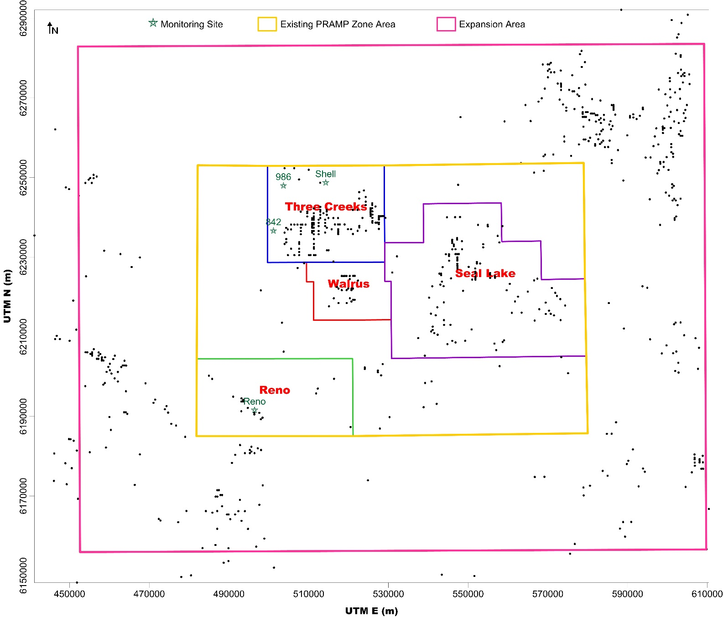
Figure 1 Example plot of source location
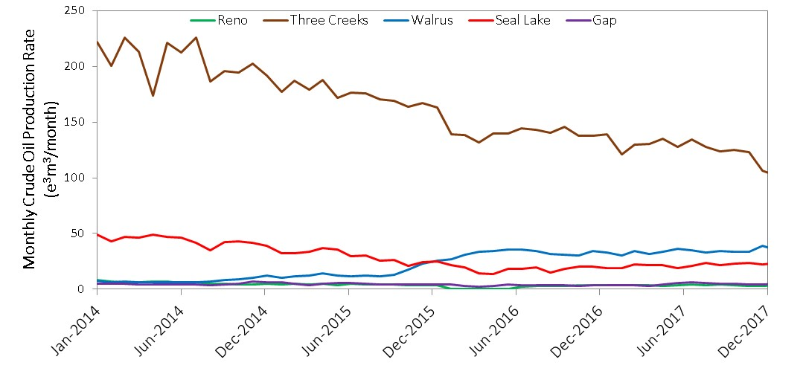
Figure 2 Example production time series plot

Task 5 Deliverables
Deliverables will include:
- A brief memo report documenting the methodology – data sets and procedures – and results
- Time series graphics and maps of source locations like Figures 1 and 2
- Excel data files of the following information in the expanded PRAMP area:
  - A Petrinex-like file for AER well and facility data, 2010 to 2018
  - 2016 NPRI emissions
  - Community population and emissions
  - Traffic segment counts and emissions

Schedule
The locations of emission sources in the NPRI emission database, community and transportation databases and the locations of currently active wells and facilities in the AER database will be prepared by 30 November 2018.

The remainder of the deliverables – production and emissions time series plots and maps, and the memo – will be prepared when 2018 AER data is available, estimated to be by the end of February 2019.

Cost Estimate
Our estimated cost to complete this work is $19,400 which includes the cost of the AER ST60 data for four years. The estimated cost is broken down by task and individual in the attached Excel sheet. GST is not included and will be itemized on each invoice. Invoices will be prepared monthly. The estimate assumes no issues with AER data download.

