VOC Sample Collection Chain of Custody Protocol

Purpose

The purpose of this document is to unambiguously define the process for ensuring proper documentation of VOC canister samples triggered as part of air monitoring in the Peace River region. All parties associated with the sample collections and reporting are asked to follow the Chain of Custody Protocol.

This document is intended to be used (and updated accordingly) with the following document:
- Canister Change out Instruction – PRAMP 842 Station
- Canister Change out Instruction – PRAMP 986 Station
- Canister Change out Instruction – PRAMP Reno Station

Canister Inventory Tracking Sheet

Maxxam will maintain and update the “Canister Inventory Tracking Sheet” spreadsheet. The purpose of this sheet is to keep track of which canisters are at site, when they expire, and when they have been triggered and collected. The spreadsheet includes the following:
- Canister ID
- Date Sent from Innotech Alberta Lab (if available)
- Date Evacuated
- Expiry Date (3 months after Date Evacuated)
- Canister Status (Current/Inventory)
- Date Triggered
- Action Required (if the canister is expired or close to expiry and needs to be sent back to Innotech)
- Name and company who performs canister change out

Canister Event Tracking List

Maxxam will maintain and update the “Canister Event Tracking List” spreadsheet. The purpose of this sheet is to keep track of all the canister events. The spreadsheet includes the following:
- Date/Time and NMHC concentration of a canister event
- Date/Time of canister being changed out
- Name of the person who performs canister change out

Chain of Custody Process
 | Notification of Trigger Events | Canister Change-out | Tracking of Canister Events
Maxxam | Maxxam included notes in the daily email indicating if a canister has been triggered or not, as well as the time and concentration for any canister triggered.  Maxxam send alert by email to local trailer contacts as well as PRMAP Technical Program Managers (TPM).  Maxxam resends email to original email list as well as calls the personnel listed on the Call-Down List id no response within 4 hours.  Maxxam escalates to PRAMP TPM if no response within 24 hours of initial notification. | Provides technical assistance if required during change-our:  Chris Wesson 780-446-2724  Limin Li 403-483-5295 | Maxxam to maintain Canister Inventory Tracking sheet for each trailer.  Maxxam to provide the up-to-date Canister Event Tracking Sheet by the end of the month each month to PRAMP TPM.
PRAMP | PRAMP Committee is included on the daily email distribution list.
PRAMP TPM | PRAMP TPM to be contacted by Maxxam if no response from Local Trailer Contacts within 24 hours of initial notification.
Call Down List Contacts | Receives alert from Maxxam and confirms with Maxxam the canister will be changed | Changes out canister according to Canister Change Out Instructions posted in the trailer.  Fills in the Analysis Request Form. Sends the canister to Innotech Lab.  Notifies Maxxam when the canister will be changed and confirm the time the canister is changed.
Innotech Alberta Lab |  |  | Conducts analysis. Sends results to Karla, PRAMP TPMs and PRAMP Office Manager.  Results to include:  * Analytical results (PDF and Excel)  * Canister Analytical Request Form (copy from the field)

Canister Trigger – Contact List

 | PRAMP 986 Station | PRAMP 842 Station | PRAMP Reno Station
Maxxam –  Sends out canister change out request in daily data | Adewunmi Adekanmbi  403-219-3677  aadekanmbi@maxxam.ca  Michael Espiritu  587-439-1525  mespiritu@maxxam.ca  Limin Li  403-219-3679  LLi@maxxam.ca | Adewunmi Adekanmbi  403-219-3677  aadekanmbi@maxxam.ca  Michael Espiritu  587-439-1525  mespiritu@maxxam.ca  Limin Li  403-219-3679  LLi@maxxam.ca | Adewunmi Adekanmbi  403-219-3677  aadekanmbi@maxxam.ca  Michael Espiritu  587-439-1525  mespiritu@maxxam.ca  Limin Li  403-219-3679  LLi@maxxam.ca
Call Down List –  Phone Call from Maxxam until someone has confirmed the canister will be changed | Jason Parker  780-618-4333  Jason.parker@cnrl.com  Robyn Kutz-Semeniuk  780-617-7937  Robyn.KutzSemeniuk@cnrl.com  Tye Barrett  780-886-2994; 780-624-6826  Tye.barrett@cnrl.com | Travis Tiffin  780-618-5098  travis.tiffin@pennwest.com  Roland Young  780-625-6275  roland.young@pennwest.com  Greg Kent  780-618-8904  greg.kent@pennwest.com  Tom Bissell  780-617-0131  tom.bissell@pennwest.com  Art Laurin  780-536-6570  art.laurin@pennwest.com | Jesse Gauchier  780-617-4347  jesse.gauchier@baytex.ab.ca  John Hickley  780-625-2057  john.hickley@baytex.ab.ca  Reno South  Jesse Gauchier  John Hickley  780-625-1402
PRAMP TPM –  To be contacted if there is no response from Local Trailer Contacts within 24 hours of email | Mike Bisaga / Lily Lin  780-266-7068  587-225-2248  pramptech@prampairshed.ca | Mike Bisaga / Lily Lin  780-266-7068  587-225-2248  pramptech@prampairshed.ca | Mike Bisaga / Lily Lin  780-266-7068  587-225-2248  pramptech@prampairshed.ca

Example of Canister Event Tracking List

PRAMP 842 Station
Non-Methane Hydrocarbons High Alarm Record
Trigger set at 0.3 ppm
Event |  |  | Canister Change Out |  |  | Notes
Date | Time | Reading | Date | Time | Performed By

Example of Analysis Request Form

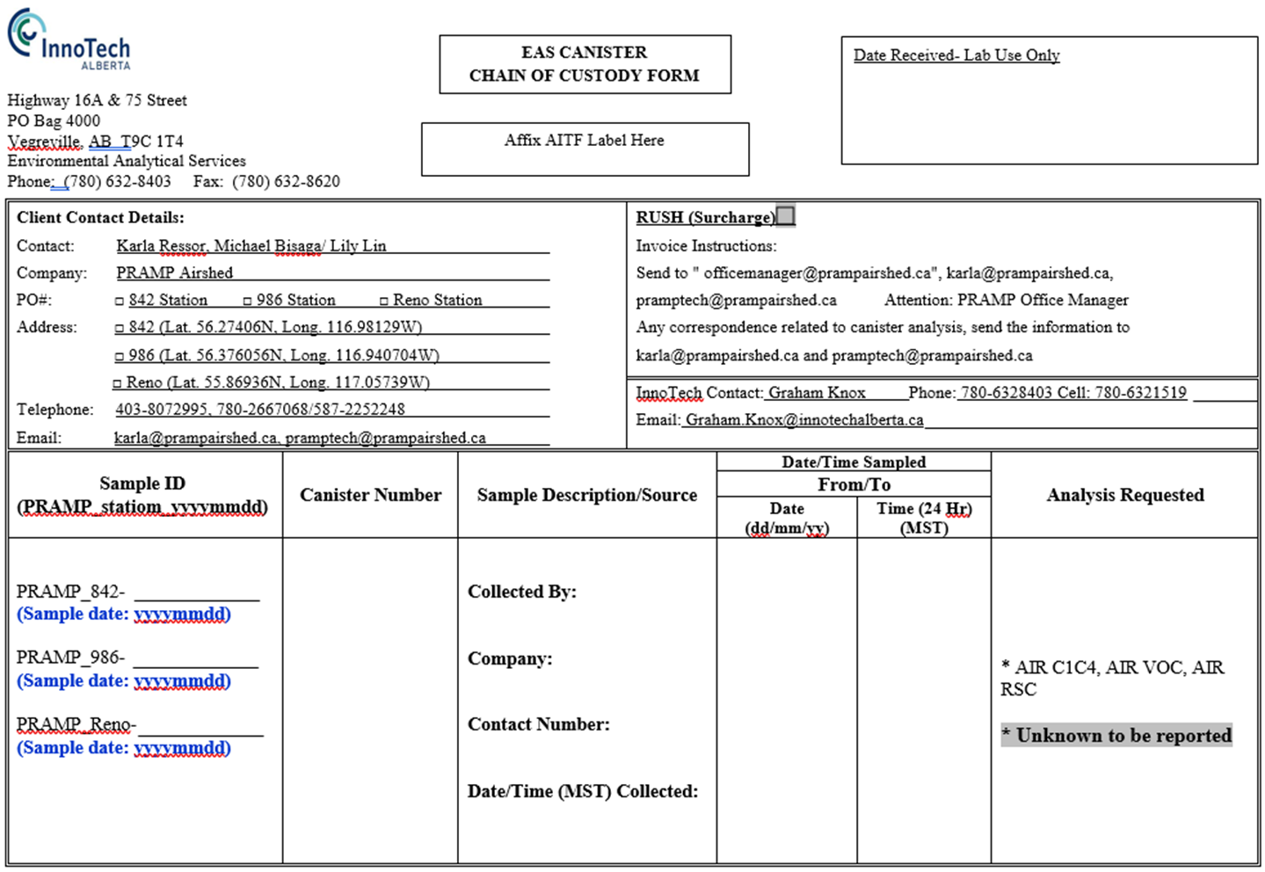

Example of Canister Change Out Instruction
